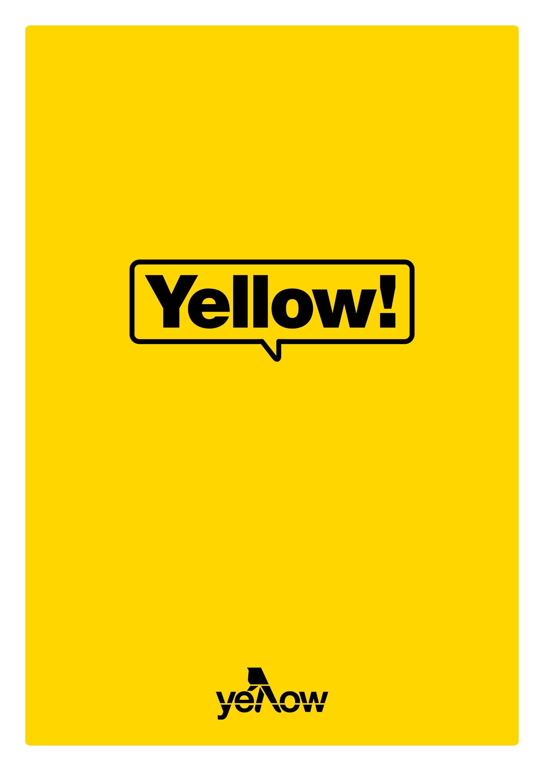

Listicle template.

'Listicle' is a word bloggers use to describe any content piece that includes a list of some sort. Readers like these articles because they’re easy to read and often provide lots of useful information—like a list of resources, tips, or 'hacks'.

Other listicles are just for fun. They might be a ranking of some sort or a list of popular books, movies, television or other aspects of pop culture. These fun types of list often get very high engagement and are a great way of showing a more personal side of your business.

There are so many different types of lists you can write, so do some brainstorming to figure out what sort of list would be most useful or interesting for your audience. Here are a few ideas we’ve come up with, which are applicable to many different types of businesses:

- 15 websites to help you _________
- 8 predictions for ________ in 2020
- 11 hilarious memes about _________
- 17 things you can do today to make _____________ easier
- 100 quick tips to help you ______________
- 16 things we wish we’d known before ___________
- 19 tricks your __________ doesn’t want you to know
- 15 times people did _____________
- 5 YouTube videos that will make you ____________
- 7 fictional characters that ____________
- 25 of the best ways to ______________
Listicle template.
# [List title].

Your headline should include the number of the list first and then a succinct writeup (65 words or so) of what the list is about.

Introduction.

Before you dive into the list, give your readers a brief introduction (no more than 300 words) discussing the general topic of the article.

This is a good time to list out any criteria you used to compile the list. (Example: We asked every one of our electricians for their favourite tips for home lighting.)

If applicable, you can also feature a call-to-action in your introduction. (Example: If you find any of these tips useful, we’d love to hear from you. Get in touch to tell us about your experience and see how we can help you … )

1. First list item.
(Include an image, video clip, etc. if applicable.)
Website: www.website.com
Price: $00.00
Rating: 4.5 stars
Recommended for: People who want to ________

The bulk of your article will feature the items on your list, but you want to do more than simply list them out one by one. For each item, write one or two paragraphs about that item on your list, explaining why you’ve included it.

You can also give quick facts underneath each item, as we have done here. This is particularly useful if you are listing out resources or recommendations, as people can easily scan your content to compare the list items.

2. Second list item.
(Include an image, video clip, etc. if applicable.)

Remember to number your list in the way that makes the most sense. If it’s just an ordinary list you can start with 1, but if it’s a ranking of some sort (like the top 10 dog breeds for first-time pet owners), you might want to start with the highest number on the list and move down. This method will keep people reading to see what made the number one slot.

Conclusion.

At the end of your article write a brief conclusion (100 – 300 words).

