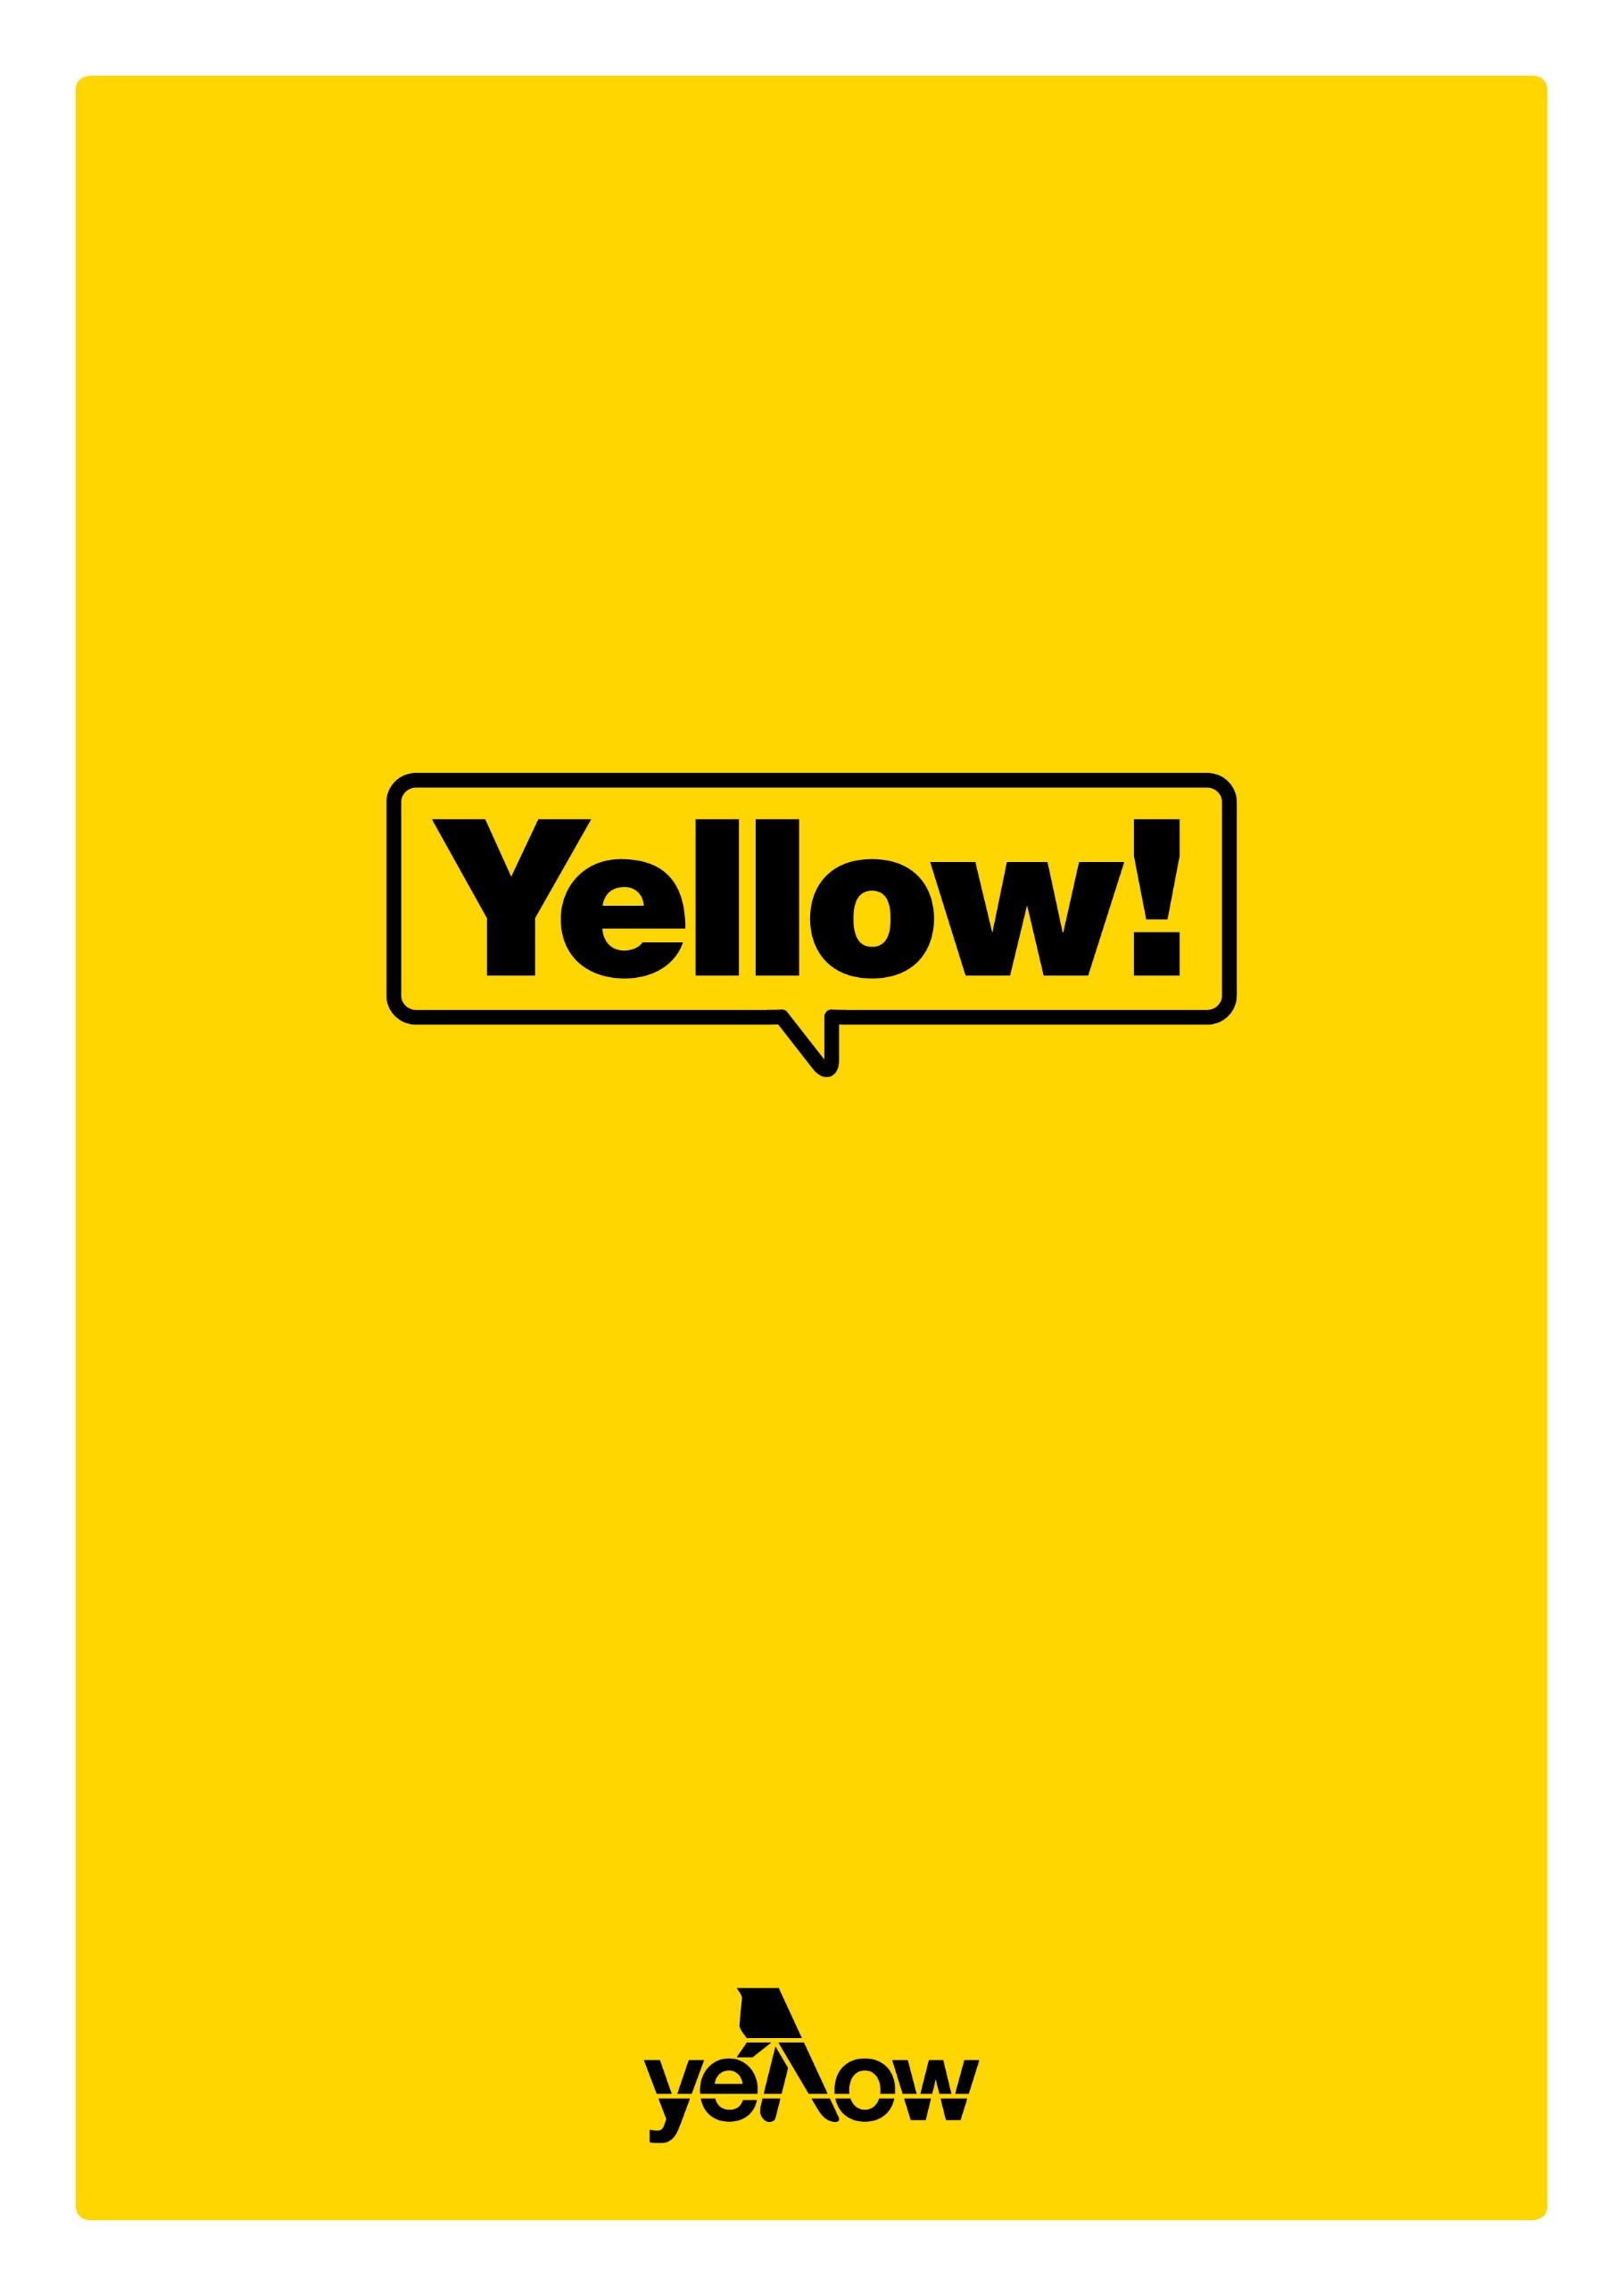

Case study template

A case study is one of the best ways to show your audience the true value of your products or services. With this type of blog article, readers get to see your business in action—how your team rose to the challenge to help a customer or client achieve a goal or improve their life.

When it comes to crafting a good case study, hard data and customer anecdotes will help you make your case. However, you don’t simply want to list facts and figures—a case study should tell a story from beginning to end. You want readers to put themselves in the shoes of the subject to the extent they’ll decide to make a purchase of their own.

The subject of your case study should be a customer or client who has mostly (if not entirely) positive things to say about their experience with your business. Consider the subject as a writing partner of sorts—you’ll be the one composing the case study, but it’s the customer’s experience and insights that make it work.

Visuals are also very effective in case studies. If you have screenshots of important metrics, product photos or images of the customer/client using your products or services, include them to make your point even clearer to your audience.

Case study template.

Title of case study.
Your title (five to ten words) should feature the name of the business and highlight the core success you’ll be discussing. (Example: How [product name] helped [customer name] double his income in six months.)

Introduction.

The introduction of the case study should give readers a quick rundown of the main takeaways you plan to discuss in the full article—you want to give just enough information to make readers see the benefits from the outset, but leave out enough that they’ll keep reading to figure out exactly how you helped your client/customer.

You may want to include a bulleted list containing the main facts of the case study, like this:

- Client/customer name
- Company size (if it’s a business case study)
- Product/service/solution name
- Statistic showing their success

The challenge (200 - 300 words).

The first section of your case study should give an overview of the challenge your customer or client faced. Start off with a sub-header that lays out the problem. (Example: Sally was juggling two jobs and struggling to make ends meet.)

Wrap up this section by briefly discussing what the client or customer needed at this stage. (Example: Sally knew if she could find a way to manage all of her finances in one place, she’d sleep easier at night.)

The solution (300 - 500 words).

Next, walk the reader through the solution you provided to the client or customer. This section is your chance to show the reader exactly what your customer service was like, and how your products/services work.

Remember to continue the story you started in the first section. Begin by telling the audience how the customer became aware of your business, then move on to how your business swooped in to save the day. Add in details about who within the business helped your customer and be sure to link to any products or services you mention as you write.

The results (300 - 500 words).

This section shows the audience what happened after you provided your service or solution. Now is the time to pull in any hard data you have to show success. Did your customer have more time on their hands? Did they get new business in the door? Did they save enough money to finally go on that vacation they’d been planning?

Clearly outline the benefits for the reader so they can imagine reaping those same rewards if and when they become your customer.

Conclusion and CTA (100 - 300 words).

In the conclusion you want to show the reader how the case study you’ve outlined could apply to them if they decide to purchase your products or services. Remind the reader that this case study is just one of many and that you’re here to help them too.

Your call-to-action should be directly related to the case study at hand. For example, if your case study is about a specific product, you might include a CTA like: ‘Does Sally’s situation sound familiar? You can start tracking your finances today with our [link to product/service]’.

